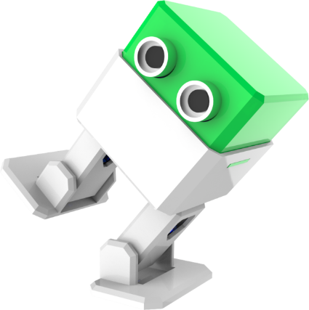
Robotics 9/10 – Course Outline
The robots are coming! No, really they are. The world is at the leading edge of a robotic/automation revolution the scale of which is simply hard to fathom. Now being propelled by advances in Artificial Intelligence and Deep/Machine Learning, robotics is poised to change our world and our worlds of work as we know them to be.
Robotics 9/10 will introduce you to the concept of robots and all that is involved in designing, building and programming them. We will be using some cool tools that are in fact forms of robots themselves, 3D printers and our Laser Cutter/Engraver to create robots.
Much of what fascinates many about robots is movement. Movement in robotics involves the control of motors and in Robotics 9/10 we will focus on the use and control of two types, Direct Current Motors and Servo Motors. We will utilize DC motors to create an ‘autonomous’ car and Servo motors to create a ‘Biped’ robot.
These are exciting times for those involved in robotics and hopefully you will find your work in this course both interesting and inspiring.
Course Length
This is a term length 2 credit course (quarter year), however it will run the entire semester every other day.
Grades
- Community Contribution 10
- Daily Engagement 30
- Projects 60
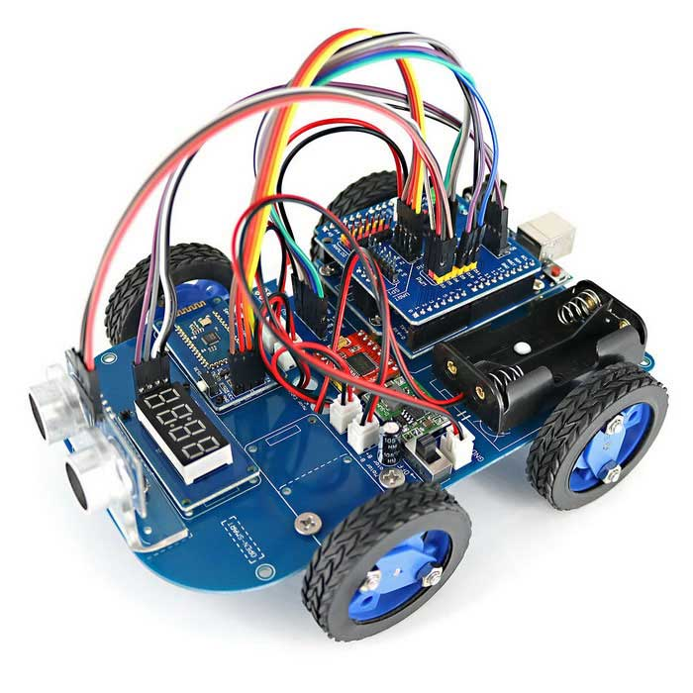
Cost
This course is free to take. However, the projects that you will be making cannot be offered for free, the costs are simply too high. You do not need to pay for a project if you do not want to keep it. If you do choose to keep it a cost will be determined based on the components used. Any project you wish to keep will need to be paid for prior to the project going home.

